
The Rising Cost of Prescription Drugs: Smart Ways to Save
October 2025
Want to attract and keep top talent? Your benefits package
is crucial! Think beyond just health and retirement.

Empowering employees to become smarter benefits consumers pays off for everyone, leading to better health outcomes and lower costs.

No doubt about it, prescriptions are expensive. While this may not be a big worry when you're young and healthy, the costs can add up quickly if you're diagnosed with a chronic condition or need an expensive drug. Whether you take medications regularly or for an occasional illness, it pays to know how to save money on prescriptions.

Did You Know?

Drug costs are a primary driver of rising healthcare expenses for both employers and employees. Prescription drug spending is consistently growing at a faster rate than overall healthcare costs, with a steady increase of 6.8%. As the fastest-growing part of benefits plans, these costs will continue to climb with new pharmaceutical innovations.

For years in the U.S., cost has been a significant obstacle to sticking with medications with up to 3 in 10 people reporting that they do not take their medications as prescribed.

The Rising Cost of Prescriptions

Historically, prescription drug costs have outpaced total healthcare costs. The following chart highlights this trend from 2019 to 2024.

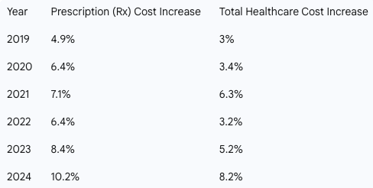
Prescription drug costs can put a strain on your budget, but with a little research and the right questions, you can reduce expenses without sacrificing your health.


October 2025

Here are expert-backed strategies to help you save on your medications:
- Ask About a Generic Drug – Get the same quality and active ingredient as you’d find in a brand name, for less money.
- Save Money with a Pill Splitter – If your prescription comes in a higher dose that can be safely split, you get 2 doses for the price of 1.
- Consider a Combo Pill – Combining two drugs into one pill can help you avoid paying separate copays or coinsurance. Ask if a combo pill is an option for you.
- Buy in Bulk – Opt for a mail-order pharmacy to get a 90-day supply of your meds instead or a 30-day supply. This can often reduce your copay and overall cost.
- Make a List and Check it Twice – Check the list of preferred medications (a.k.a. “the formulary”), which tend to cost less.
- Find Out if You Still Need That Medication – If you’ve been taking the same medication for years, it’s worth checking in with your doctor to see if you still need it. Or if you’ve made a lifestyle change, it may reduce your need for certain medications. It never hurts to ask your doctor.
The medicines prescribed by your doctor are essential to your good health. With some savvy shopping, you can use the money you save on the things you enjoy!



